Scene Analysis- Machine vision

Wengun Gui Vinay Bhapkar Lakshay sharma
New York University New York University New York University
Email ids: Email id Email id

Abstract—Abstract of the whole paper
Keywords-YOLO,ZED
The paper proposes a novel approach towards Point of Tell, Scene Understanding and Guidance towards the desired object. The idea behind scene understanding for our project is quite simple. ZED camera had a built-in extension for running YOLO- a deep learning object detector in Python 3. The application gives a real-time feedback of all the objects that are present in the environment.
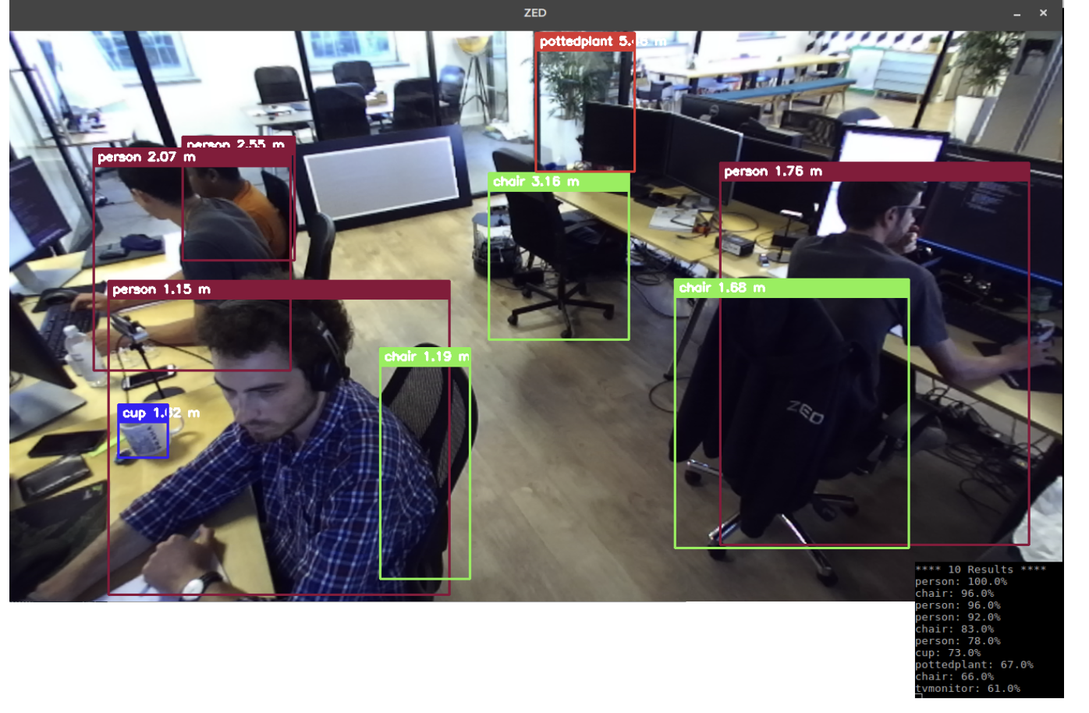
Once we obtain the understanding of our environment, we combine these objects into a list. This list is passed to a Text to Speech converter module. List is iterated over each object and is converted into a voice signal. This enables a low vision person to hear the objects which are present in their environment.

(It will automatically be converted to RSS format when we add References and Acknowledgement)

